**Project Report: Personal Portfolio Website**

Offer leter

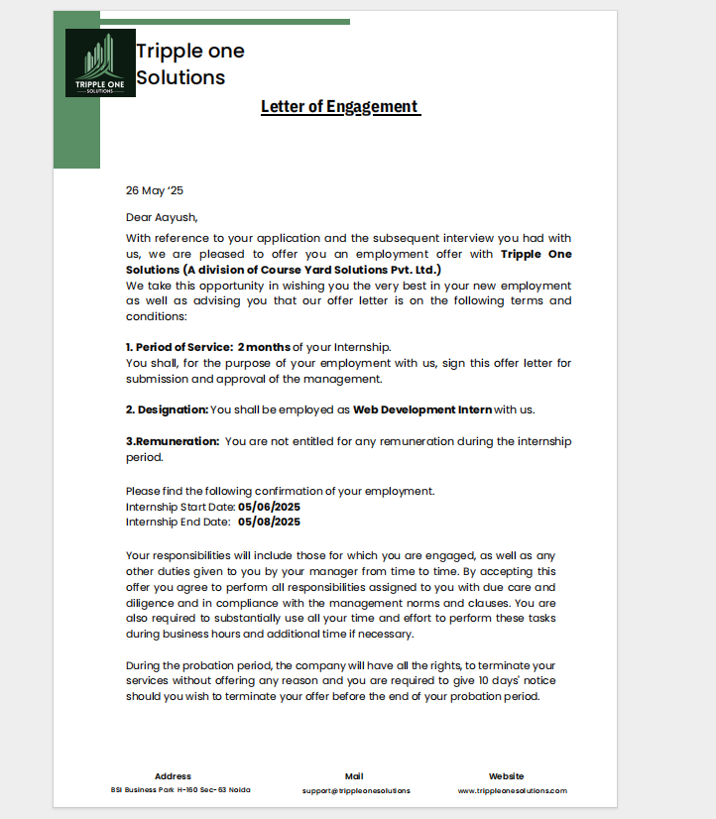

# 

# 1. Project Title

**Personal Portfolio Website**

# 2. Introduction

## Project Overview

The **Personal Portfolio Website** is a digital platform developed to showcase my skills, academic and professional background, and projects in an interactive and visually appealing manner. It functions as an online resume and a point of contact for potential employers, clients, or collaborators. **Objective**

The objective of the project is to design and develop a **fully responsive, user-friendly, and visually attractive** website using front-end web technologies. The website aims to provide an organized and professional representation of:

* Personal introduction
* Technical skills
* Project portfolio
* Contact form

# 3. Motivation

In today's digital age, having a personal website significantly enhances visibility and professionalism. This project was motivated by the need to:

* Build an online presence
* Practice and demonstrate web development skills
* Create a live portfolio to share with recruiters and clients

# 4. Methodology

**Technology Purpose**

**HTML5** Structural foundation of the web content

**CSS3** Styling, layout, responsiveness, and visual design

**Bootstrap 5** Front-end framework for responsive grid and UI components

**JavaScript** Interactivity (e.g., form validation, smooth scroll)

**GitHub Pages** Deployment and hosting of the static website

# 5. Application Architecture

**Structure**

The website is a **Single Page Application (SPA)** divided into the following sections:

* **Home:** Introduction and call-to-action
* **About:** Personal details, background, and skills
* **Projects:** Portfolio of work
* **Contact:** Form and details to reach out **Responsive Design**

The layout is responsive using:

* **Bootstrap grid system**
* **CSS media queries**
* Mobile-first design approach

# 6. Features

|  |  |
| --- | --- |
| **Section** | **Description** |
| **Home** | Welcome message, name, tagline, and CTA button |
| **About** | Background, education, skills, and interests |
| **Projects** | Gallery of projects with titles, descriptions, and GitHub/demo links |
| **Contact** | Contact form with JavaScript validation, email input, and message box |
| **Smooth Scroll** | Enhances navigation between sections with a seamless transition |
| **Footer** | Contact details and copyright notice |

# 7. Deployment Hosting

The site is hosted on **GitHub Pages**, which allows free hosting of static websites. **Domain**

A custom domain (e.g., yourname.com) can be linked for a more professional presence.

**Version Control**

All development is managed using **Git**, allowing easy collaboration, rollback, and version tracking.

**8. Highlighted Project – To-Do App**

One of the featured projects on the portfolio is a **To-Do App**.

**Project Name: To-Do List Web App**

**Description:**

A lightweight, user-friendly web application that helps users manage tasks by adding, editing, and deleting to-do items.

**Features:**

* Add new tasks
* Mark tasks as completed
* Delete tasks
* Real-time updates using JavaScript
* Responsive design using Bootstrap

**Technologies Used:**

* HTML5
* CSS3
* JavaScript
* Bootstrap

# 9. Challenges Faced

* Ensuring consistent layout across all devices
* Managing Bootstrap classes for responsive grid structure
* Implementing form validation with plain JavaScript
* Hosting setup and domain configuration

# 10. Learning Outcomes

* Practical understanding of **HTML, CSS, JavaScript, and Bootstrap**
* Experience with **responsive design**
* Understanding of **client-side architecture**
* Familiarity with **Git version control** and **GitHub Pages deployment**

# 12. Future Enhancements

* Add a **Dark/Light mode toggle**
* Integrate **backend (e.g., PHP or Firebase)** for storing contact form responses
* Create a **blog section** for articles or tutorials
* Add **animations using AOS or GSAP** for improved interactivity

# 11. Conclusion

The **Personal Portfolio Website** project successfully meets its goal of showcasing my skills and projects in a structured and interactive format. It reflects my ability to build responsive websites and apply front-end development skills effectively. This project has laid a solid foundation for future work in web development and digital branding.

Internship Certificate

